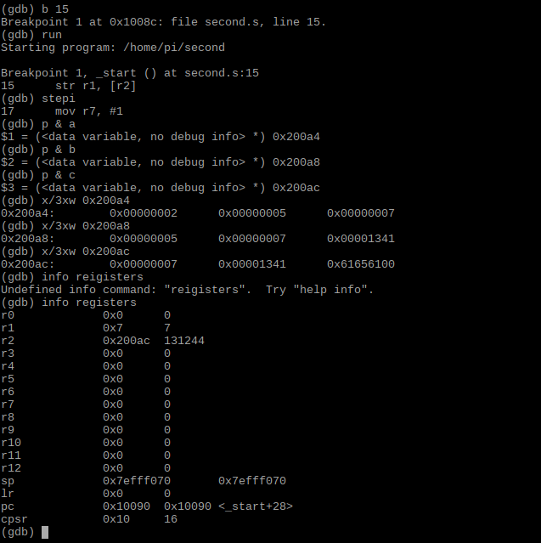

With command “p & c”, we can see that memory c has address of 0x200ac, by looking up the info registers, r2 has the memory address of c(0x200ac), which verified the step “ldr r2, =c”. And then, we store r1 into memory c, so that memory c now has the value of r1, which completes the formula “ c=a+b”. We checked the result with command” x/3xw 0x200a4”. This command gives us the 3 words in hexadecimal starting from the memory location of a. We are having 0x00000002(memory a), 0x00000005(memory b), 0x00000007(memory c), which verified the program(7=2+5).

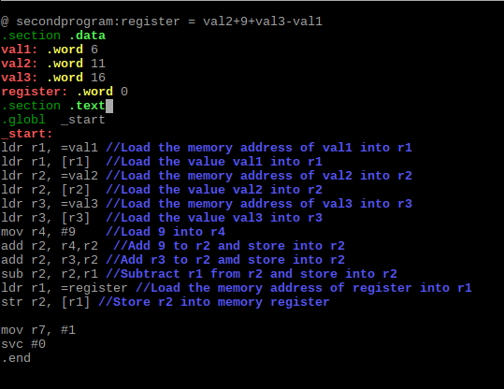

For this program, i assigned 4 variables val1,val2,val3 and register, and giving them value 6,11,16 and 0, respectively. Then, i load the memory address of each memory into different registers, and load the value of each memory into different registers as well. I also load another register(r4) to store 9, and add r4 to r2 and store into r2(val2+9=11+9=20, val2=20). Then, i add r3 to r2 and store into r2(val2+val3=20+16=36, val2=36). I subtracted r1 from r2 and store into r2(val2-val1=36-6=30,val=30). Last, i load the memory address of register into r1 and store r2 into memory register(register=30).

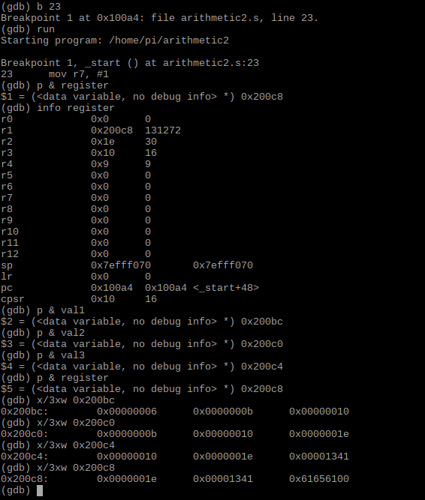

By debugging the program, we can see that r1 has address of 0x200c8, which is the address of “register” . Starting from address 0x200bc and 0x200c0, which is the address of val1 and val2, we can see that 0x00000006(val1),0x0000000b(val2),0x000000010(val3),0x0000001e(register). Converting to decimal we will have 6, 11, 16 , 30, respectively, which verified our program, 11+9+16-6=30, in which val2=11, val3=16, val1=6 and register=30.